**Experiment 32**

**AIM :**

To design NFA transition diagram that start and end with different alphabets in automata.

**Design and output:**

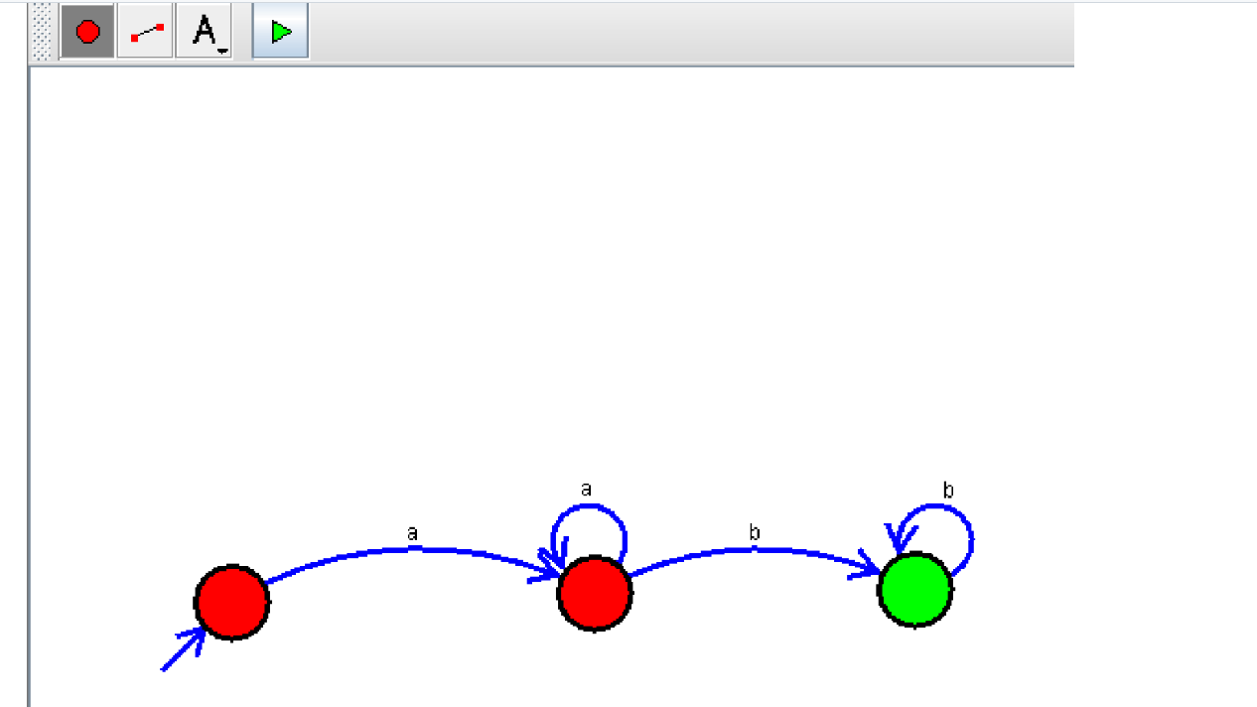

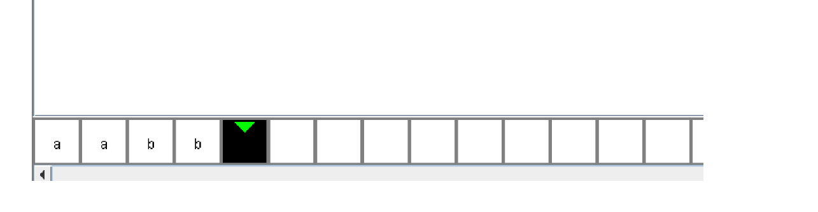

**Result:** Thus designing NFA transition diagram that start and end with different alphabets is done and verified by giving sample inputs.